

THE UNIVERSITY OF QUEENSLAND

Faculty of Engineering, Architecture and Information Technology

[Concept Report]

Student Name: [XiangLong, LIN]
Sheershak KUMAR,
Aayush AGGARWAL,
Nur Adam Ariff ALDRIN,
Vennkkata Reddi CHEEMALAPATI
& Naren GUGANATHAN
Course Code: ENGG1100

Course Coordinator: A/Prof Saiied Aminossadati

Submission date: [21 March 2021]
A/Prof Saiied Aminossadati ENGG1100 Course Coordinator EAIT
The University of Queensland Queensland 4072

Dear Sir,

I, [XiangLong LIN], am the author of this assignment, [Concept Report].

I warrant that no third-party copyrights or legal rights are infringed by my assignment.

All the work contained within this Assignment is my/my team original work except where otherwise acknowledged.

Signature [ ]
Student ID/s: [45791439]

Executive Summary
This report introduces the background information, lists the problems to be solved to design the different prototypes, and through the corresponding scoring criteria for each prototype to score in each test item, and finally get a comprehensive ranking and select the scheme.

Table of Contents
Executive Summary i
Table of Contents ii
List of Tables iii
List of Figures iv
1. Introduction 1
1.1 Background Information 1
1.2 Aims and Objectives 1
1.3 Problem Definition 1
1.4 System Overview 3
2. DESIGN CRITERIA 4
3. DESIGN OPTIONS 5
3.1 Prototype 1 5
3.2 Prototype 2 5
3.3 Prototype 3 5
3.4 Prototype 4 5
4. EVALUATE AND VALIDATE 6
5. CONCLUSIONS AND RECOMMENDATIONS 7
References 8

List of Tables
Table 1: Example Evaluation Table 4
Table 2: Evaluation Table 2 6

List of Figures
Figure 1: Printed Circuit Board (Aminossadati, 2021) 2
Figure 2: Test Space Specifications (Aminossadati, 2021) 2
Figure 3: Test Space Schematic (Aminossadati, 2021) 3

Introduction

1.1 Background Information
The structure of a vehicle compares favorably with the heart of a human body which is linking all viscera together, every subsystem of a vehicle can only be connected with each other based on the structure, in order to get the basis and premise to work. Meanwhile, the structure of a firefighting vehicle also plays an indispensable role to support the whole fire extinguishing process.

University of Michigan (2021) claims that the number of infrastructure systems responding to natural disasters has unprecedentedly increased, this requires the development of new multidisciplinary analysis, design and manufacturing methods for various structural systems and materials. This shows that it is necessary to research and design the new structure of firefighting vehicle in many aspects, which will lead the rescue vehicle to a higher level in essence, so that the vehicle can face and eliminate the fire danger more efficiently.

1.2 Aims and Objectives
The main aim of this report is to design a feasible firefighting vehicle with relatively high cost-performance ratio. The essential steps are dived into the following five parts:
- Understand and always design around the conditions and limitations set for the four main parts: Vehicle, Fire Extinguisher, Budget and Test space.
- Tangibly understand each task assigned in this project.
- Design unique prototypes by comprehending and reference relevant literature on the design of firefighting vehicle to draw inspiration.
- Integrate and contrast the designed prototypes in many aspects, and finally select one that is best suited.

1.3 Problem Definition
Aminossadati (2021) reports the Australian Aviation Rescue Fire Fighting Service (ARFF) has the most professional firefighting team, which includes their ability to respond to emergencies in 3 minutes. While at Brisbane Airport ,80 firefighters will respond to the emergency of 2,700 hectares. This also shows that firefighting vehicle is the prerequisite for allowing firefighters to intervene quickly in emergencies in case of fire or other circumstances. (State Government NSW, 2019) These are enough to indicate that the use of the firefighting vehicle directly affects the efficiency of the firefighting team, whether the function of firefighting vehicle is strong will affect whether the fire can be suppressed and eliminated in time. Therefore, this project sets a series of restrictions on the firefighting vehicle, the test space and the combustion sources, in order to ensure that fire engines have the necessary functions and features.
- Vehicle:
  - Maximum length is 300mm (fully assembled).
  - Maximum width is 200mm (fully assembled).
  - Maximum height is 300mm (fully assembled).
  - Maximum total mass with 1 L water is 3 kg.
  - The drive, fluid delivery and structural subsystem must be included within the vehicle.
  - Control mechanisms and batteries can be installed outside of the vehicle. The mass of anything external to the vehicle will not be counted in the total mass.
  - Batteries, which is DC power and not exceeding 13 V, is needed to provide power and keep the firefighting vehicle working for at least 6 minutes.
  - Control mode can be semi-automatic or fully automatic.
  - Components and Printed Circuit Board (PCB) from the classes could be applied. (Figure 1)
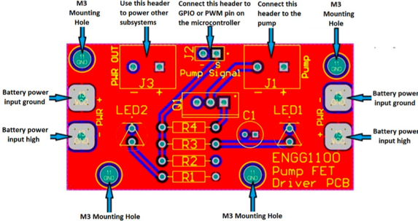
Figure 1: Printed Circuit Board (Aminossadati, 2021)
- Fire Extinguisher:
  - Water under ordinary temperature is used as the firefighting fluid.
- Budget:
  - The total cost of the prototype should not exceed AU$150, the excess will result in the loss of the total design score.
  - The final cost must comprise all the components.
  - Each team will be asked to submit a formal budget report on the Demonstration Day with relative documents.
- Test Space:
  - The test space is 1400 mm X 2400 mm. (Figure 2)
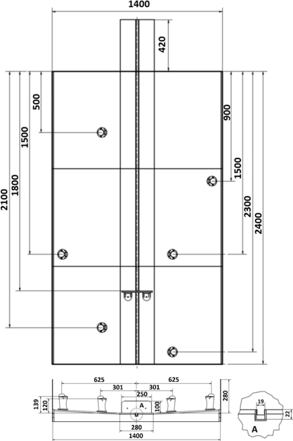
Figure 2: Test Space Specifications (Aminossadati, 2021)
  - The firefighting vehicle will be operated on the central line of the test space.
  - Six combustion sources of different distances and altitudes will be located on the test space. (Figure 2)
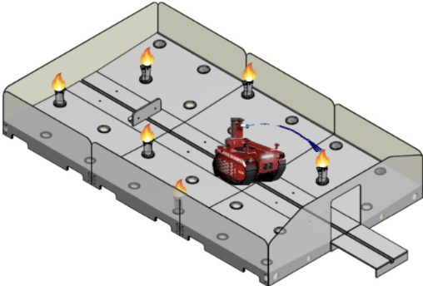
Figure 3: Test Space Schematic (Aminossadati, 2021)

1.4 System Overview
The firefighting vehicle need to be designed to achieve particular goals under certain restrictions in many ways:
- Drive Subsystem:
  - Travel forward and backward.
  - Run with a steady and controllable speed.
  - Stop and run at any time.
  - Keep rectilinear motion.
- Fluid Delivery Subsystem:
  - Transfer water from a tank in a low level to a nozzle in a high level through pressurised pump.
  - Spray a certain amount of water by a nozzle to cool down the combustion source at a specific angle, range, and mode.
- Control Subsystem:
  - Manipulate the drive subsystem and the fluid delivery subsystem through the mechanisms.
  - Actualize automation to some extent.
- Structural Subsystem:
  - Be compatible with and supportive to the drive subsystem, the fluid delivery subsystem and partial control subsystem.
  - Be firm and stable enough.
  - Support the entire vehicle during movement and injection process.

DESIGN CRITERIA
- This report focuses on structural subsystem for discussion and design.
Structural subsystem is mainly divided into four main cores for assessment:
  - The presentation of the structural subsystem.
  - The height of the firefighting vehicle.
  - The stability of the firefighting vehicle.
  - The applicability of the firefighting vehicle.
- This report assesses the prototype in three ways (functionality, durability and cost):
  - First, consider 4 as the highest class, 3 as the second class, 2 as the third class and 1 as the lowest class and then grade each test item for each prototype.
  - Then the weighted grade is calculated by different specific gravity.
  - Finally, the three weighted grades are added together to get the combined score.
  - The prototype with the highest combined score will be selected because it means that the synthesis rank is the highest.
Table 1: Example Evaluation Table
Evaluation Item  Prototype | Functionality (80%) | Durability (60%) | Cost (40%)
1
2
3
4

Design OPTIONS
Suppose the layouts of the other 3 subsystems is the same, and different prototypes are proposed for chassis selection

3.1 Prototype 1
The first scheme is to design the chassis as a relatively simple rectangle, rectangular structure does not need redundant processing process. But there will be a short board in stability and practicability.

3.2 Prototype 2
The second scheme is to design the chassis into a triangle, because the stability of the triangle is the strongest, so there is a relatively higher ability to give adequate support in the operation and injection of the firefighting vehicle. But the loaded area is very limited.

3.3 Prototype 3
The third is to design the chassis as circular, because within the same material consumption, the design of the chassis as circular can effectively increase the loaded area, so that the chassis has more space to load other subsystems. But the circular design is likely to make the firefighting vehicle unable to enter the space forming a certain angle, which limits its range of activities.

3.4 Prototype 4
The fourth design is to design the chassis as elliptical, referring to the design similar to the bullet head, in air flow, which can effectively make the fire engine move quickly in the fire scene to carry out rescue work. And the circular design also allows the chassis to load more component. But similarly, the oval will block the firefighting vehicle's movement in the space because of its irregular shape.

Evaluete and Validate
According to different shapes of chassis designs, they will bring different benefits to firefighting vehicle, but also the corresponding disadvantages. The use of tables will clearly present the advantages and disadvantages of each scheme in terms of its specific nature.
Table 2: Evaluation Table
Evaluation Item  Prototype | Functionality (80%) | Durability (60%) | Cost (40%)
1 | 1 | 1 | 4
2 | 3 | 4 | 3
3 | 2 | 3 | 2
4 | 4 | 2 | 1
As a result, the combined ratings of each prototype are as follows:
- Prototype 1: 1 X 80% + 1 X 60% + 4 X 40% = 3
- Prototype 2: 3 X 80% + 4 X 60% + 3 X 40% = 6
- Prototype 3: 2 X 80% + 3 X 60% + 2 X 40% = 4.2
- Prototype 4: 4 X 80% + 2 X 60% + 1 X 40% = 4.8
Therefore, Prototype 2 > Prototype 4 > Prototype 3 > Prototype 1.

Conclusions and Recommendations
According to the final calculation results, it can be seen that designing the chassis into a triangular shape can obviously enhance the stability of the whole firefighting vehicle when moving and spraying. At the same time, because of the strong stability of the triangle can effectively prevent the chassis from falling apart. Although triangle chassis cost to process the original base material, it would still be necessary since this pprototype will bring effective functionality and durability to achieve the goals in this project.

References
Aminossadati, S. (2021) ENGG1100 Learning Guide, Course Blackboard Site, The University of Queensland, Australia.
Civil and Environmental Engineering University of Michigan, Structural and Materials Enginnering, viewed 21 March 2021, <https://cee.engin.umich.edu/research/infrastructure/structure-materials/>.
State Government NSW, 2019, Fire safety guideline Access for fire brigade vehicles and firefighters, viewed 21 March 2021.

